“Transfiguration of the Lord”

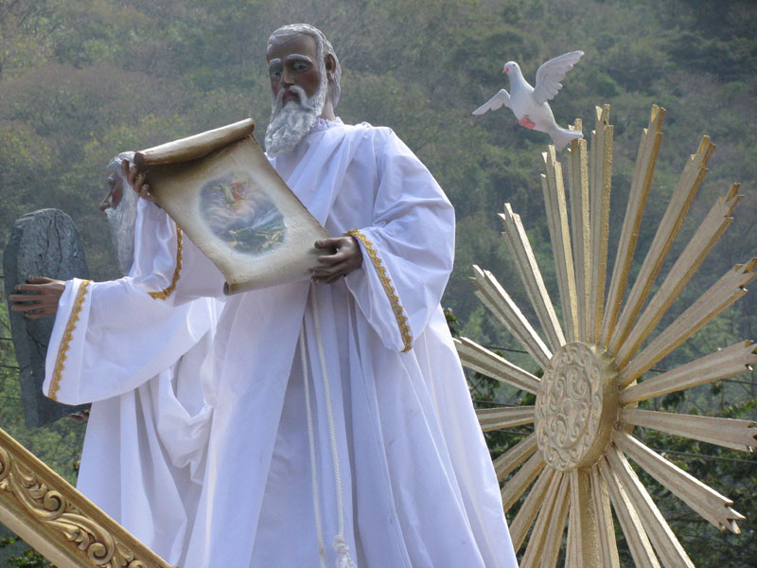
Anonymous. Moses, Procession of the Transfiguration, from Art in the Christian Tradition,
a project of the Vanderbilt Divinity Library, Nashville, TN.

Glen Echo Christian Church (D.O.C.)
February 15, 2026

Glen Echo Christian Church
(Disciples of Christ)
February 15, 2026
Gathering Music
Welcome and Announcements Everleigh Brunner
Greeting One Another in Christian Love
(Please return to your seats to worship when the lights flash.)
PRELUDE Martin Smith/arr. Bill Wolaver
“I Could Sing Of Your Love Forever”

*CALL TO WORSHIP
One: Climb the mountain of God.
All: We will watch and wait.
One: Wait for God’s glory to shine like the sun.
All: Wait for Christ to reveal the heart of God.
One: Wait to gain courage for the terror of the night.
All: Wait for the Spirit to dispel the darkness.

*HYMN OF PRAISE #203 “Here Hangs a Man Discarded” vv.1-3

*INVOCATION

*GLORY TO GOD #34
Gloria, gloria, in excelsis Deo! Gloria, gloria, alleluia, alleluia!

FIRST READING Exodus 24:12-18 page 62

PRAYER HYMN #218 “Thine Is the Glory”

PASTORAL PRAYER & LORD’S PRAYER (debts)

SPECIAL MUSIC

CHILDREN’S MOMENT Pastor Aaron Brunner

SECOND READING Matthew 17:1-9 page 798

SERMON “Transfiguration of the Lord” Pastor Aaron Brunner

HYMN OF PREPARATION #384 “Here, at Thy Table, Lord”

Invitation to Commune Justin Brunner Communion Sentences
One: With tenderness and grace, Jesus shows us the glory of God.
All: We walk in the assurance of God’s mercy, and the
promise of Christ’s strength for the journey.
Prayer of Consecration
(Please partake of the Bread of Life and the Cup of Salvation.)
COMMUNION MUSIC
*INVITATION AND HYMN OF DEDICATION
#241 “Holy Spirit, Truth Divine”
BENEDICTION Pastor Aaron Brunner
*Please stand, if able.
___________________________________________________________________________

Prayer Requests
Mary Margaret Bierma
Julie Bonner: Angie Ross
Myssie Brunner: Her father’s mother
Josh Ingram: Uncle Barry
Virginia Johnson
Bev Katzmann: Jordan; Michael
Rosemarie Kelling, and her brother, Hans-Martin
Juanita Leggett: Her son and daughter
Teresa Little: Cousin Dave; Don’s mother
Deb Martin: Darla Welch; Shelly Wilson
Dennis Martin: Lori Martin
Lori Martin: neighbor, Julie Peterson; Dennis
Carol Miller
Jackie Murphy
Agatha Norton
Margaret Ripperger
Ron Smith
Bill Suiter
Alicia Tottser: Cora
Bev Van Blaricome

Upper Midwest Regional Weekly Prayers
* First Christian Church, Oskaloosa, IA; Robert & Molly Goodrich
* North English Christian Church, North English, IA; Luke Caster
* Gary Hesser, Jay Hillestad
* Week of Compassion
Events for This Week
February 15–21, 2026
Sunday  Wednesday | Worship  Coffee Fellowship  Ash Wednesday Service | 10: 15 am  After church  6:00 pm
News in the Pews
Birthdays and Anniversaries:
February 16 – Allison Martin
21 – Joan Weiser

Who to Contact: For general concerns or questions, please contact our President, Justin Brunner. If you would like to speak with the pastor, please contact Aaron Brunner (515-954-5280), email him at aaronbrunner833@yahoo.com, or write to him at 1325 NE 50th Place, Des Moines, IA 50313. You can also call the church (515-274-9124).

Portions of the worship service were adapted from:
The Abingdon Worship Annual 2026. Copyright © 2025 by Abingdon Press. Used by permission.

