“Be Still and Know”

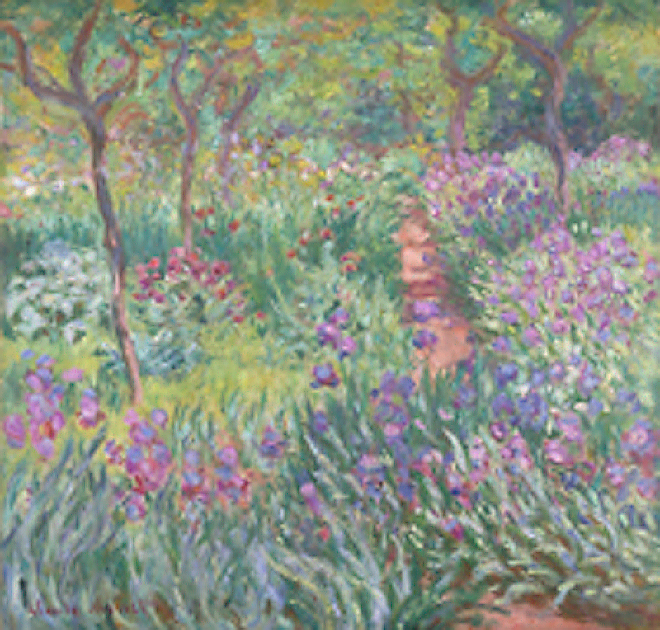
Monet, Claude, 1840-1926. Artist's Garden at Giverny, from Art in the Christian Tradition,
a project of the Vanderbilt Divinity Library, Nashville, TN.

Glen Echo Christian Church (D.O.C.)
February 8, 2026

Glen Echo Christian Church
(Disciples of Christ)
February 8, 2026
Gathering Music
Welcome and Announcements Kayla Brunner
Greeting One Another in Christian Love
(Please return to your seats to worship when the lights flash.)
PRELUDE

*CALL TO WORSHIP
One: Happy are those who delight in the Lord!
All: We come to this place, where generations before us
have gathered.
One: Here we remember the light of God that shines in our lives.
All: Here we allow God’s light to shine through us.

*HYMN OF PRAISE #113 “Jesus Loves Me!”

*INVOCATION

*GLORY TO GOD #34
Gloria, gloria, in excelsis Deo! Gloria, gloria, alleluia, alleluia!

FIRST READING Psalm 46 page 450

PRAYER HYMN #550 “There's Within My Heart a Melody”

PASTORAL PRAYER & LORD’S PRAYER (debts)

SPECIAL MUSIC

CHILDREN’S MOMENT Pastor Aaron Brunner

SECOND READING Matthew 5:13-20 Page 786

SERMON “Be Still and Know” Pastor Aaron Brunner

HYMN OF PREPARATION #284 “Gather Us In”

Invitation to Commune Kathleen Smith Communion Sentences
One: Holy One, search us and reveal your truths to us.
All: May your Spirit help us truly comprehend your
message for us today.
Prayer of Consecration
(Please partake of the Bread of Life and the Cup of Salvation.)
COMMUNION MUSIC
*INVITATION AND HYMN OF DEDICATION
#572 “Take Time to Be Holy”
BENEDICTION Pastor Aaron Brunner
*Please stand, if able.
___________________________________________________________________________

Prayer Requests
Julie Bonner: Angie Ross
Kathy Hooper: Emma Dunham’s family and friends
Virginia Johnson
Bev Katzmann: Jordan; Michael
Rosemarie Kelling, and her brother, Hans-Martin
Juanita Leggett: Her son and daughter
Teresa Little: Cousin Dave; Don’s mother
Deb Martin: Darla Welch; Shelly Wilson
Dennis Martin: Lori Martin; Cousin Kelly
Lori Martin: neighbor, Julie Peterson
Carol Miller
Jackie Murphy
Agatha Norton
Margaret Ripperger
Ron Smith
Trevor Sprague & Cassino Company
Bill Suiter
Alicia Tottser: Cora
Bev Van Blaricome

Upper Midwest Regional Weekly Prayers
* Central Christian Church, Boone, IA; Clayton Boyd
* River Valley Disciples, Johnston, IA
* Marvin Fortune, Larry Squier
* Christian Church in Oklahoma
Events for This Week
February 8–14, 2026
Sunday | Worship  Souper Bowl Lunch | 10: 15 am  After church
News in the Pews
Birthdays and Anniversaries:
February 12 – Virginia Johnson

Who to Contact: For general concerns or questions, please contact our President, Justin Brunner. If you would like to speak with the pastor, please contact Aaron Brunner (515-954-5280), email him at aaronbrunner833@yahoo.com, or write to him at 1325 NE 50th Place, Des Moines, IA 50313. You can also call the church (515-274-9124).

Souper Bowl: We will have a soup dinner after the worship service today.

Good Fellowship: Our Good Fellowship Dinner will be on February 13th at Felix & Oscars on Merle Hay Road at 5:45 p.m. Please sign up in the hallway to tell us how many friends and family you are bringing.

Portions of the worship service were adapted from:
The Abingdon Worship Annual 2026. Copyright © 2025 by Abingdon Press. Used by permission.

