“The Tenets of Our Faith”

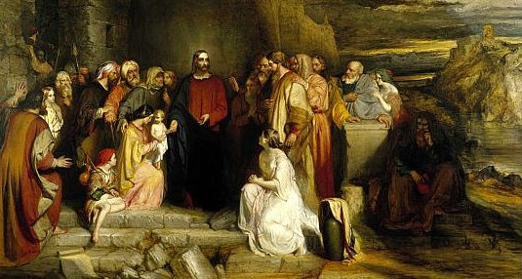
Caravaggio, Michelangelo Merisi da, 1573-1610. Calling of Saints Peter and Andrew, from Art in the Christian Tradition, a project of the Vanderbilt Divinity Library, Nashville, TN.

Glen Echo Christian Church (D.O.C.)
February 1, 2026

Glen Echo Christian Church
(Disciples of Christ)
February 1, 2026
Gathering Music
Welcome and Announcements Julie Bonner
Greeting One Another in Christian Love
(Please return to your seats to worship when the lights flash.)
PRELUDE

*CALL TO WORSHIP
One: What does the Lord require of us?
All: To do justice, love kindness, and walk with our God.
One: How shall we live our faith?
All: With actions that bring peace, and works that lift up
the lowly.

*HYMN OF PRAISE
#605 “For Each Day of Life We Thank You”

*INVOCATION

*GLORY TO GOD #34
Gloria, gloria, in excelsis Deo! Gloria, gloria, alleluia, alleluia!

FIRST READING Micah 6:1-8 page 757

PRAYER HYMN #586 “Open My Eyes, That I May See”

PASTORAL PRAYER & LORD’S PRAYER (debts)

SPECIAL MUSIC

CHILDREN’S MOMENT Pastor Aaron Brunner

SECOND READING Matthew 5:1-12 Page 785

SERMON “The Tenets of Our Faith” Pastor Aaron Brunner

HYMN OF PREPARATION #284 “Gather Us In”

Invitation to Commune Alex Brunner Communion Sentences
One: God is stronger than our weaknesses, greater than our failings.
All: Even when we fall short, God’s love embraces us and
sets us on the path of life once more.
Prayer of Consecration
(Please partake of the Bread of Life and the Cup of Salvation.)
COMMUNION MUSIC
*INVITATION AND HYMN OF DEDICATION
#434 “God Be with You till We Meet Again”
BENEDICTION Pastor Aaron Brunner
*Please stand, if able.
___________________________________________________________________________

Prayer Requests
Julie Bonner: Angie Ross
Kathy Hooper: Emma Dunham’s family and friends
Virginia Johnson
Bev Katzmann: Jordan; Michael
Rosemarie Kelling, and her brother, Hans-Martin
Juanita Leggett: Her son and daughter
Teresa Little: Cousin Dave; Don’s mother
Deb Martin: Darla Welch; Shelly Wilson
Dennis Martin: Lori Martin; Cousin Kelly
Lori Martin: friend, Kathy
Carol Miller
Jackie Murphy
Agatha Norton
Margaret Ripperger
Ron Smith
Trevor Sprague & Cassino Company
Bill Suiter
Alicia Tottser: Cora
Bev Van Blaricome

Upper Midwest Regional Weekly Prayers
* Stanhope Parish, Stanhope, IA; Justin Crocheck
* First Christian Church, Perry, IA; Andrea Brownlee, Crystal Nelson
* Tammy Tychsen, Dave Neas
* Christian Church in North Carolina
Events for This Week
February 1–7, 2026
Sunday | Worship  Coffee Fellowship  Deacon Callers Meeting | 10: 15 am  After church  After church
News in the Pews
Birthdays and Anniversaries:
February 3 – Lexi Karl

Who to Contact: For general concerns or questions, please contact our President, Justin Brunner. If you would like to speak with the pastor, please contact Aaron Brunner (515-954-5280), email him at aaronbrunner833@yahoo.com, or write to him at 1325 NE 50th Place, Des Moines, IA 50313. You can also call the church (515-274-9124).

Souper Bowl: We will have a party following the worship service on the 8th of February.

Directory Update: Please add Rev. Tony & Lisa Thurston to your directories. Their address is: 4301 43rd Street, Des Moines, IA 50310. They can be reached at 515-313-6373 or tonyt9706@gmail.com.

Good Fellowship: Our Good Fellowship Dinner will be on February 13th at Felix and Oscars on Merle Hay Road at 5:45 p.m. Please sign up in the hallway to tell us how many friends and family you are bringing.

Portions of the worship service were adapted from:
The Abingdon Worship Annual 2026. Copyright © 2025 by Abingdon Press. Used by permission.

