“Faith vs. Works”

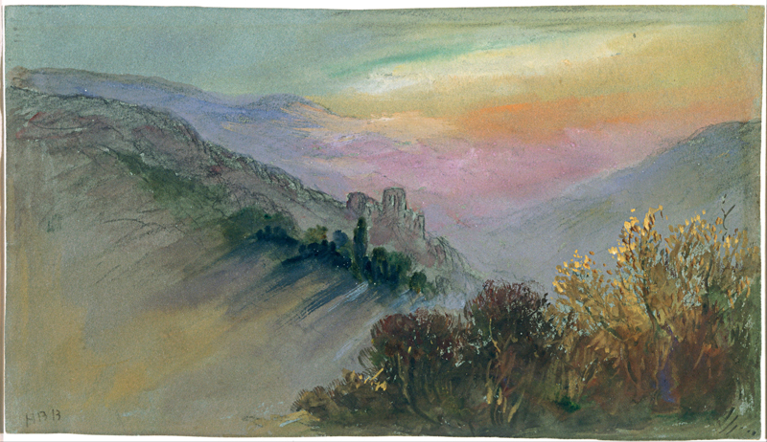
Brabazon, Hercules Brabazon, 1821-1906. Mountain Landscape, from Art in the Christian Tradition, a project of the Vanderbilt Divinity Library, Nashville, TN.

Glen Echo Christian Church (D.O.C.)
March 1, 2026
Glen Echo Christian Church
(Disciples of Christ)
March 1, 2026
Prelude
Welcome and Announcements Julie Bonner
Greeting One Another in Christian Love
(Please return to your seats to worship when the lights flash.)

*CALL TO WORSHIP
One: God calls us to set out in faith.
All: The love of God leads us home.
One: Christ blesses us that we might bless others.
All: The blessings of Christ heal our world.

*HYMN OF PRAISE #249 “Spirit”

*INVOCATION

*GLORIA PATRI #36
Glory be to the Father, and to the Son, and to the Holy Ghost;
As it was in the beginning, is now, and ever shall be,
World without end. Amen. Amen.

FIRST READING Genesis 12:1-4 page 8

PRAYER HYMN #272 “The Church's One Foundation”

PASTORAL PRAYER & LORD’S PRAYER (debts)

SPECIAL MUSIC

CHILDREN’S MOMENT Pastor Aaron Brunner

SECOND READING Romans 4:1-5, 13-17 page 916

SERMON “Faith vs. Works” Pastor Aaron Brunner

HYMN OF PREPARATION #100 “When Morning Gilds the Skies”

Invitation to Commune Myssie Brunner Communion Sentences
One: God calls us and blesses us,
All: That we might share our blessings with others.
Prayer of Consecration
(Please partake of the Bread of Life and the Cup of Salvation.)
COMMUNION MUSIC
*INVITATION AND HYMN OF DEDICATION
#33 “How Great Thou Art”
BENEDICTION Pastor Aaron Brunner
*Please stand, if able.
___________________________________________________________________________

Prayer Requests
Mary Margaret Bierma
Kayla Brunner: Heather
Myssie Brunner: Her father’s mother
Josh Ingram: Uncle Barry
Virginia Johnson
Bev Katzmann: Jordan; Michael
Rosemarie Kelling, and her brother, Hans-Martin
Juanita Leggett: Her son and daughter
Teresa Little: Don’s mother
Deb Martin: Darla Welch; Shelly Wilson
Dennis Martin: Lori Martin
Lori Martin: neighbor, Julie Peterson; Dennis
Carol Miller
Jackie Murphy: Carol
Agatha Norton
Dorothy Perry: Alice Spicer
Margaret Ripperger
Ron Smith
Bill Suiter
Alicia Tottser: Cora
Bev Van Blaricome

Upper Midwest Regional Weekly Prayers
* First Christian Church, Ames, IA; Janet Lott
* First Christian Church, St. Paul, MN; Dennis Sanders, Teresa
Pecinovsky
* Amanda Sorenson, Tammy Rottschaefer, Corrine Welsch
* Black Minister’s Retreat
Events for This Week
March 1–6, 2026
Sunday | Worship  Coffee Fellowship  Deacon Callers Meeting | 10: 15 am  After church  After church
News in the Pews
Birthdays and Anniversaries:
March 5 – Teresa Little

Directory Update: Carol Miller’s address is 5824 Northglenn Drive
Unit B, Johnston, IA 50131. Her current number is (515) 528-9131.

Regional Minister Josh Patty will be attending our next board meeting on March 10th at 7:30 pm. You are each invited to express your thoughts and share your concerns with our regional minister.

Good Fellowship: We will be doing the Good Fellowship dinner in March at the church as a potluck. Please sign up if you would like to join, and if you would like, sign up for a dish or dessert to bring to share!

Travel Schedule: Pastor Aaron will be travelling during the last two weeks of March. Pastors Shirley Lockard and Tony Thurston will fill in.

Ministers’ Institute: It will be meeting on March 2nd – 3rd for anyone interested in growth and learning. Please see Pastor Aaron for details.

Best Practices: To help ensure that we have a welcoming and comforting experience for everyone during our service, we wanted to share some best practices. Please silence the ringer on your cell phone during the service. Please be mindful with fragrances worn, as we have multiple members of our congregation that have sensitivities. This includes any perfume, cologne, scented lotions, etc. Lastly, please keep conversations to a minimum during service, especially during meditations and silent prayers out of respect for others.

Portions of the worship service were adapted from:
The Abingdon Worship Annual 2026. Copyright © 2025 by Abingdon Press. Used by permission.

