“The Fast God Chooses”

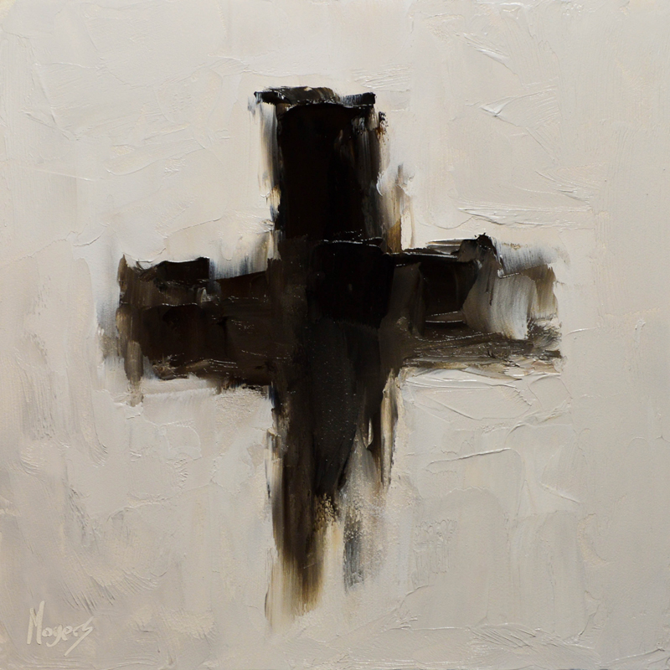
Moyers, Mike. Ash, from Art in the Christian Tradition,
a project of the Vanderbilt Divinity Library, Nashville, TN.

Glen Echo Christian Church (D.O.C.)
Ash Wednesday
February 18, 2026
Glen Echo Christian Church
(Disciples of Christ)
February 18, 2026

PRELUDE

WELCOME & PRAYERS

HYMN #659 “What Does the Lord Require for Praise”

SCRIPTURE READING Isaiah 58:1-12 page 600

SERMON “The Fast God Chooses” Pastor Aaron Brunner

DISPENSATION OF THE ASHES
(Please come forward down the center aisle, pick up a small plastic cup filled with ashes, and apply the ashes to your forehead or hand. Then dispose of the cup in the receptacle by the table and return to your pews by the side aisles.)
BENEDICTION

