“The Temptation of Lent”

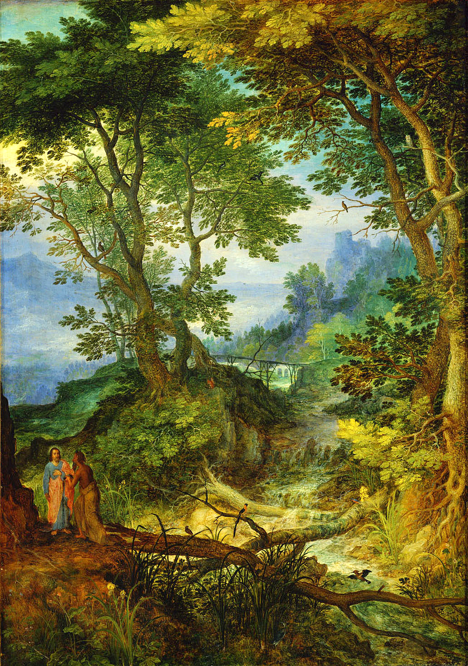
Bruegel, Jan, 1568-1625. Mountain Landscape with the Temptation of Christ, from Art in the Christian Tradition, a project of the Vanderbilt Divinity Library, Nashville, TN.

Glen Echo Christian Church (D.O.C.)
February 22, 2026
Glen Echo Christian Church
(Disciples of Christ)
February 22, 2026
Prelude
Welcome and Announcements Kathleen Smith
Greeting One Another in Christian Love
(Please return to your seats to worship when the lights flash.)

*CALL TO WORSHIP
One: Be glad in the Lord and rejoice.
All: Steadfast love surrounds those who trust the Lord.
One: When we confess our transgressions, Christ’s grace and
forgiveness encompass us.
All: Steadfast love surrounds those who trust the Lord.
One: Open yourselves to the teachings and wisdom of the Spirit.
All: Steadfast love surrounds those who trust the Lord.

*HYMN OF PRAISE #179 “Forty Days and Forty Nights”

*INVOCATION

*GLORY TO GOD #34
Gloria, gloria, in excelsis Deo! Gloria, gloria, alleluia, alleluia!

FIRST READING Psalm 32 page 440

PRAYER HYMN #180 “Lord, Who Throughout These Forty Days”

PASTORAL PRAYER & LORD’S PRAYER (debts)

SPECIAL MUSIC

CHILDREN’S MOMENT Pastor Aaron Brunner

SECOND READING Matthew 4:1-11 page 785

SERMON “The Temptation of Lent” Pastor Aaron Brunner

HYMN OF PREPARATION #284 “Gather Us In”

Invitation to Commune Kayla Brunner Communion Sentences
One: We seek to follow you, dear Jesus, through the wildernesses of
our lives.

All: Help us to see and turn from our own temptations,
that we might offer all glory and power to you.
Prayer of Consecration
(Please partake of the Bread of Life and the Cup of Salvation.)
COMMUNION MUSIC
*INVITATION AND HYMN OF DEDICATION
#77 “On Eagle's Wings”
BENEDICTION Pastor Aaron Brunner
*Please stand, if able.
___________________________________________________________________________

Prayer Requests
Mary Margaret Bierma
Myssie Brunner: Her father’s mother
Josh Ingram: Uncle Barry
Virginia Johnson
Bev Katzmann: Jordan; Michael
Rosemarie Kelling, and her brother, Hans-Martin
Juanita Leggett: Her son and daughter
Teresa Little: Don’s mother
Deb Martin: Darla Welch; Shelly Wilson
Dennis Martin: Lori Martin
Lori Martin: neighbor, Julie Peterson; Dennis
Carol Miller
Jackie Murphy
Agatha Norton
Margaret Ripperger
Ron Smith
Bill Suiter
Alicia Tottser: Cora
Bev Van Blaricome

Upper Midwest Regional Weekly Prayers
* Carlisle Christian Church, Carlisle, IA; Kristen Pike
* First Christian Church, Spencer, IA
* Christine Isham-Walsh, Doug Burton
* Christian Church in Oregon & Southwest Idaho
Events for This Week
February 22–28, 2026
Sunday | Worship  Coffee Fellowship  Elders Meeting | 10: 15 am  After church  After church
News in the Pews
Birthdays and Anniversaries:
February 23 – Sandy Freel, Martha Moses
24 – Charles W. Collins II
26 – Kathleen Smith
27 – Kathy Hooper
28 – Lori Martin

Directory Update: Carol Miller’s address is 5824 Northglenn Drive
Unit B, Johnston, IA 50131. Her current number is (515) 528-9131.

Regional Minister Josh Patty will be attending our next board meeting on March 10th at 7:30 pm. You are each invited to express your thoughts and share your concerns with our regional minister.

Travel Schedule: Pastor Aaron will be travelling during the last two weeks of March. Pastors Shirley Lockard and Tony Thurston will fill in.

Ministers’ Institute: It will be meeting on March 2nd – 3rd for anyone interested in growth and learning. Please see Pastor Aaron for details.

Best Practices: To help ensure that we have a welcoming and comforting experience for everyone during our service, we wanted to share some best practices. Please silence the ringer on your cell phone during the service. Please be mindful with fragrances worn, as we have multiple members of our congregation that have sensitivities. This includes any perfume, cologne, scented lotions, etc. Lastly, please keep conversations to a minimum during service, especially during meditations and silent prayers out of respect for others.

Portions of the worship service were adapted from:
The Abingdon Worship Annual 2026. Copyright © 2025 by Abingdon Press. Used by permission.

